For Random Numbers

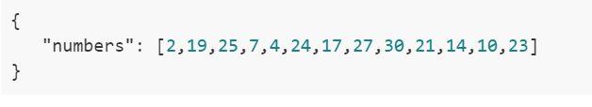

For Even Numbers

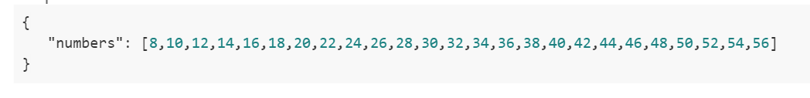

For Fibbonacci Numbers

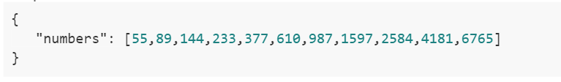

For Prime Numbers

